Mary Walters

Ergonomic Analysis

Most comfortable: Amazon Basics

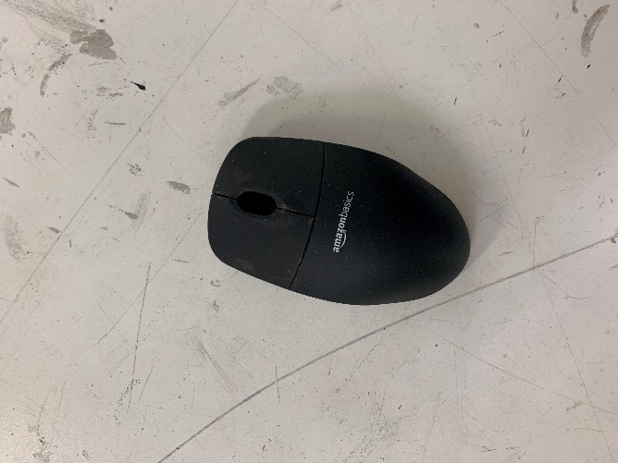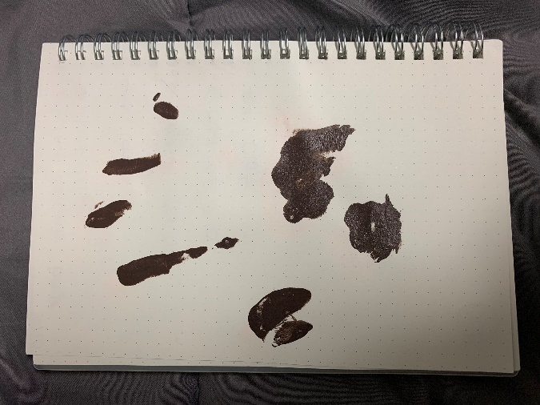

* Good size for my hand
* Comfortable for my ring finger and pinky to rest on the side
* Good contact throughout portions A, F, and E to give a sense of control when moving
* Curves and contour on the sides and edges fit my hand well

2nd: Lenovo

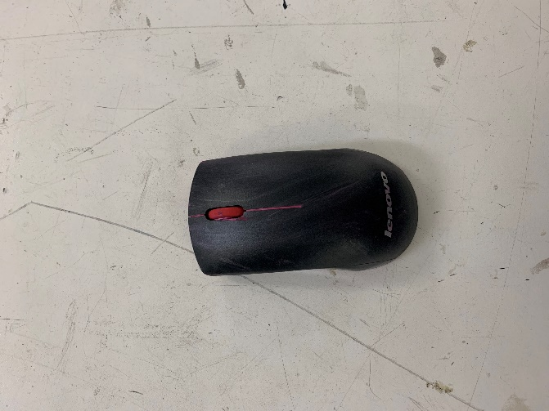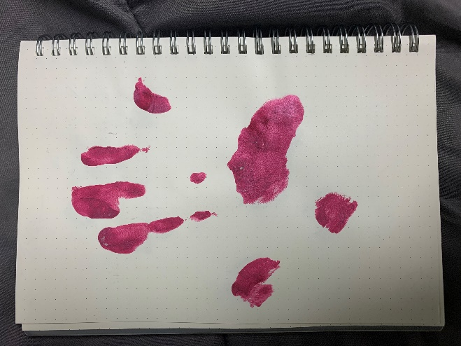

* Good size for my hand
* More contact for A1, B1, C1, D1
* I like that it narrows in the middle to rest thumb and fingers on the side
* Good palm support for F1, F2, and F3

3rd: Apple

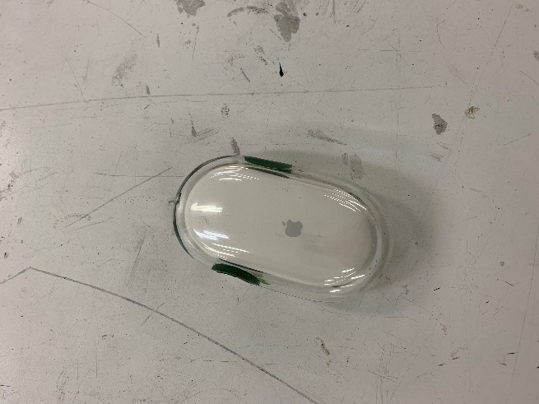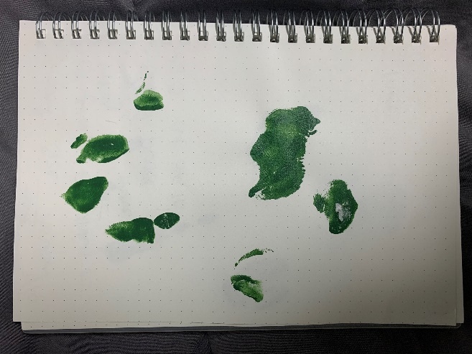

* One solid shape with no contours or curves
* Side button is awkward
* Missing contact in A1 and E1 – very important
* Good contact in F1 and F2

Least comfortable: Microsoft

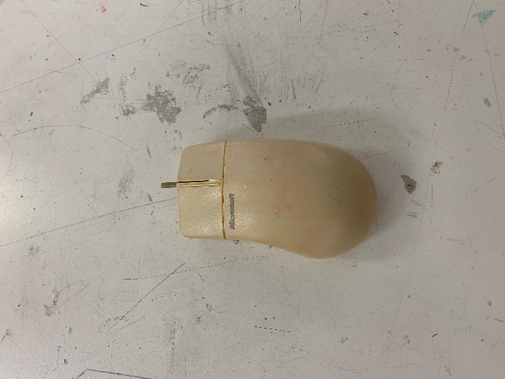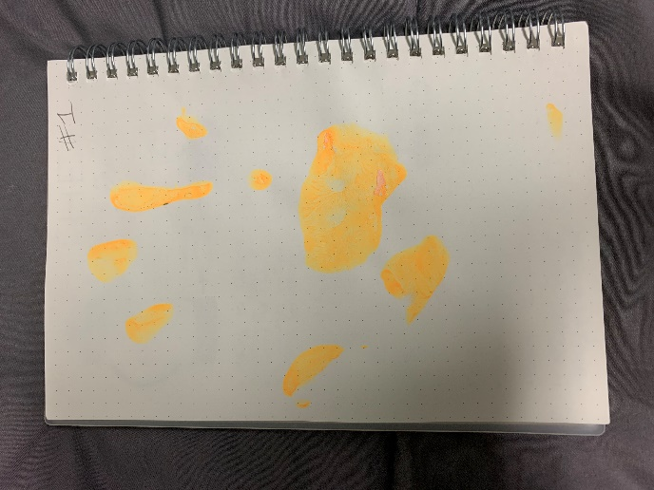

* Hits E2 very awkwardly because of the hump
* Too long – barely contact for any on A or B
* Did not feel like I could control it
* Too flat – too much emphasis on F1 and F2